(Approx. 448 words)

An Internet Safety Guide For Seniors
By Kurt Jefferson, Editor, Central Kentucky Computer Society
https://ckcs.org/
lextown2 (at) gmail.com

“The Internet can be a scary place, especially if you’re old enough to be able to remember dialing a rotary telephone!…” begins the website from Safety Detectives.

But, in reality, age doesn’t matter. Anyone using the Internet is a target.
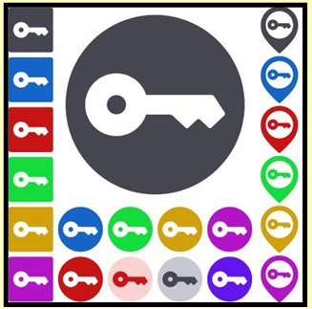
Still, those of us who are 60 and older are prime targets of cybercrimes.

(Cybercrimes are those committed over the Internet using any device and means such as email, website, or social media apps such as Facebook or Instagram.)

Stats
Think about this for a moment. In 2020, Americans 60 and older lost an estimated $1 billion due to cybercrimes. (Source: The FBI’s Internet Crime Complaint Center, IC3.)

That was a 30% increase over the prior year. Yikes!

While all of this can be quite nerve-racking, you don’t need to bite your nails or bash your head against the wall (although sometimes that’s a tempting thought.)

Protect Yourself
Safety Detectives says despite the threats, “The vast majority of cyber attacks can be easily prevented with the proper tools, some basic education, and plain old common sense.”

The Safety Detective’s website provides an excellent breakdown of common online threats facing folks who are 60 and older.
These include:
• Viruses & Malware
• Phishing
• Data breaches/password theft
• Social media scams
• Banking fraud
• Privacy violations

Mobile
If you own an iPhone, iPad, or Android phone, scroll down and check out the How to Stay Safe on Your Smartphone & Tablet section.

VPNs
VPNs (virtual private networks) will protect you when using public Wi-Fi networks.VPNs are apps you can pay for and then install.
Many are offered through the different app stores (Mac App Store, App Store, Google Play, etc.) or from the software developer’s website.

As the website notes, VPNs can flag unsafe public networks and protect your privacy by sending your Internet connection into an encrypted tunnel while on public Wi-Fi. Safety Detectives tested 52 separate VPNs and selected what it considers the best of the lot. Here are what others say:

- C|net: Best VPN Service of 2021

- Tom’s Guide: The Best VPN Service

- PCmag.com: The Best VPN Services for 2021

Password Managers
Using a solid password manager keeps you safe and can make your life easier. A good password manager can auto-fill your login and password on many websites, so you no longer have to type in that information manually. In addition, you no longer have to keep that information in a notebook or on Post–It® notes.

- IPCmag.com: Best Password Managers for 2021

- Macworld UK: Best Password Managers For Mac

- Tom’s Guide: The Best Password Managers in 2021

- Check out The (2021).

